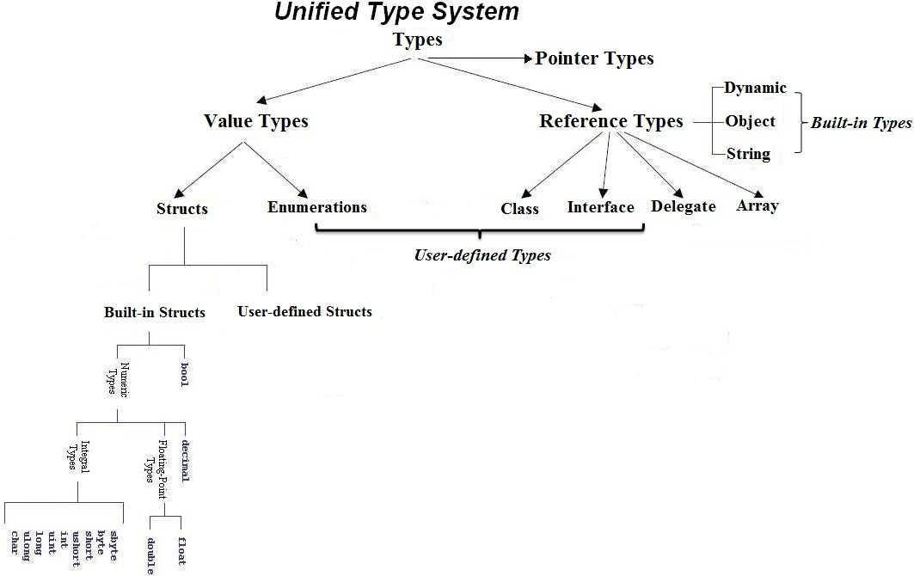

Value Types (Built-in Structs)

Integral Types
Type | Size (Bit) | Range
sbyte | 8 | -128 to 127
byte | 8 | 0 to 255
short | 16 | -32768 to 32767
ushort | 16 | 0 to 65535
int | 32 | -2³¹ to 2³¹-1  -2147483648 to 2147483647  ±2 Billion – 9 zeros)  (10 digits)
uint  U  u | 32 | 0 to 2³²-1  0 to 4294967295  (0 to 4 Billion – 9 zeros)  (10 digits)
long  L  l | 64 | -2⁶³ to 2⁶³-1  -9223372036854775808 to 9223372036854775807  (±9 Quintillion – 18 zeros)  (19 digits)
ulong  UL  ul | 64 | 0 to 2⁶⁴-1  0 to 18446744073709551615  (0 to 18 Quintillion – 18 zeros)  (19 digits)
char | 16  (Unicode)  (unsigned) | U+0000 to U+ffff  (0 to 65535)

Floating Point Types
Type | Size (Bit) | precision | Range
float  F  f | 32 | 7 digits  (excluding point and F) | ±1.5e−45 to ±3.4e38  (±1.5 x 10⁻⁴⁵ to ±3.4 x 10³⁸ )  (39 digits)
double  D / .0  d | 64 | 15-16 digits  (excluding point and D) | ±5.0e−324 to ±1.7e308  (±5.0 x 10⁻³²⁴ to ±1.7 x 10³⁰⁸)  (309 digits)

Decimal Type
Type | Size (Bit) | precision | Range
decimal  M  m | 128 | 28-29 digits  (excluding point and M) | ±1.0 × 10e−28 to ±7.9 × 10e28  (±1.0 x 10⁻²⁸to ±7.9 x 10²⁸)  (±0.0000000000000000000000000001M to  ±79228162514264337593543950335M)  (±79 Octillion – 27 zeros)  (29 digits)

Boolean Type
Type | Size (Bit) | Range
bool | 8 | true, false

Reference Types (Built-in Types)

String Type
Type | Size (Bit) | Range
string | 160+ | 0 to approximately 2 billion characters

Object Type
Type | Size (Bit) | Range
object | 64+ | All types including value types and excluding pointer types can be stored in a variable, as all types except pointer types inherit from object

Value Types (Built-in Structs)

Integral Types
C# Type | .NET Framework Type
sbyte | System.SByte
byte | System.Byte
short | System.Int16
ushort | System.UInt16
int | System.Int32
uint | System.UInt32
long | System.Int64
ulong | System.UInt64
char | System.Char

Floating Point Types
Type | .NET Framework Type
float | System.Single
double | System.Double

Decimal Type
Type | .NET Framework Type
decimal | System.Decimal

Boolean Type
Type | .NET Framework Type
bool | System.Boolean

Reference Types (Built-in Types)
String Type
Type | .NET Framework Type
string | System.String

Object Type
(Base Type of all Types including Value Types)
Type | .NET Framework Type
object | System.Object

Value Types (Built-in Structs)
Integral Types
Type | Default Value
sbyte | 0
byte | 0
short | 0
ushort | 0
int | 0
uint | 0U
long | 0L
ulong | 0UL
char | ‘\0’

Floating Point Types
Type | Default Value
float | 0.0F
double | 0.0D

Decimal Type
Type | Default Value
decimal | 0.0M

Boolean Type
Type | Default Value
bool | false

Value Types (User-defined Structs)
Type | Default Value
struct | The value produced by setting all value-type fields to their default values and all reference-type fields to null.

Value Types (Enumerations) (User-defined)
Type | Default Value
enum | The value produced by the expression (E)0, where E is the enum identifier

The C# typing system contains the following categories:
- Value types
- Reference types
- Pointer types

Variables of the value types store data, while those of the reference types store references to the actual data. Reference types are also referred to as objects. Pointer types can be used only in unsafe mode.

The value types consist of two main categories:
- Structs
- Enums
Structs fall into these categories:
- Numeric types
- Integral types
- Floating-point types
- decimal
- bool
- User defined Structs

Value Types (Built-in Structs)
Integral Types
Type | Category
sbyte | Signed, numeric, integral
byte | Unsigned, numeric, integral
short | Signed, numeric, integral
ushort | Unsigned, numeric, integral
int | Signed, numeric, integral
uint | Unsigned, numeric, integral
long | Signed, numeric, integral
ulong | Unsigned, numeric, integral
char | Unsigned, numeric, integral

Floating Point Types
Type | Category
float | Numeric, floating-point
double | Numeric, floating-point

Decimal Type
Type | Category
decimal | Numeric, decimal

Boolean Type
Type | Category
bool | Boolean

Value Types (User-defined Structs)
Type | Category
struct | User-defined structure

Value Types (Enumerations) (User-defined)
Type | Category
enum | Enumeration

Variables of reference types, referred to as objects, store references to the actual data. User-defined reference types:
- class
- interface
- delegate

Built-in reference types:
- dynamic
- object
- string

It is possible to convert a value type to a reference type, and back again to value types, by using boxing and unboxing. With the exception of a boxed value types, you cannot convert a reference type to a value type.

Value types are also nullable, which means they can store an addition non-value state.

In an unsafe context, a type may be a pointer type as well as a value type or a reference type. A pointer type declaration takes one of the following forms:

unmanaged type* identifier;
void* identifier;

Parameters

unmanaged type
One of the following:
- sbyte, byte, short, ushort, int, uint, long, ulong, char, float, double, decimal, or bool.
- Any enum type
- Any pointer type
- Any user-defined struct type that contains fields of unmanaged types only

identifier
The pointer variable name.

Pointer types do not inherit from object and no conversions exist between pointer types and object. Also, boxing and unboxing do not support pointers. However, you can convert between different pointer types and between pointer types and integral types.

The following table shows the predefined implicit numeric conversions. Implicit conversions might occur in many situations, including method invoking and assignment statements.

From | To
sbyte | short, int, long, float, double, or decimal
byte | short, ushort, int, uint, long, ulong, float, double, or decimal
short | int, long, float, double, or decimal
ushort | int, uint, long, ulong, float, double, or decimal
int | long, float, double, or decimal
uint | long, ulong, float, double, or decimal
long | float, double, or decimal
char | ushort, int, uint, long, ulong, float, double, or decimal
float | double
ulong | float, double, or decimal

The conversions from int, uint, or long to float and from long to double may cause a loss of precision, but not a loss of magnitude.

There are no implicit conversions to the char type.

There are no implicit conversions between floating-point types and the decimal type.

A constant expression of type int can be converted to sbyte, byte, short, ushort, uint, or ulong, provided the value of the constant expression is within the range of the destination type.

Explicit numeric conversion is used to convert any numeric type to any other numeric type, for which there is no implicit conversion, by using a cast expression. The following table shows these conversions.

From | To
sbyte | byte, ushort, uint, ulong, or char
byte | sbyte or char
short | sbyte, byte, ushort, uint, ulong, or char
ushort | sbyte, byte, short, or char
int | sbyte, byte, short, ushort, uint, ulong, or char
uint | sbyte, byte, short, ushort, int, or char
long | sbyte, byte, short, ushort, int, uint, ulong, or char
ulong | sbyte, byte, short, ushort, int, uint, long, or char
char | sbyte, byte, or short
float | sbyte, byte, short, ushort, int, uint, long, ulong, char, or decimal
double | sbyte, byte, short, ushort, int, uint, long, ulong, char, float, or decimal
decimal | sbyte, byte, short, ushort, int, uint, long, ulong, char, float, or double

The explicit numeric conversion may cause loss of precision or result in throwing exceptions.
When you convert a decimal value to an integral type, this value is rounded towards zero to the nearest integral value. If the resulting integral value is outside the range of the destination type, an OverflowException is thrown.

When you convert from a double or float value to an integral type, the value is truncated. If the resulting integral value is outside the range of the destination value, the result depends on the overflow checking context. In a checked context, an OverflowException is thrown, while in an unchecked context, the result is an unspecified value of the destination type.

When you convert double to float, the double value is rounded to the nearest float value. If the double value is too small or too large to fit into the destination type, the result will be zero or infinity.

When you convert float or double to decimal, the source value is converted to decimal representation and rounded to the nearest number after the 28th decimal place if required.

Depending on the value of the source value, one of the following results may occur:
If the source value is too small to be represented as a decimal, the result becomes zero.
If the source value is NaN (not a number), infinity, or too large to be represented as a decimal, an OverflowException is thrown.

When you convert decimal to float or double, the decimal value is rounded to the nearest double or float value.

